**Cybersecurity, Law, and Ethics (CSE487)**

**[Summer 2022]**

**Section: 01**

**Project Title:** Configuration of Certification Authority and Implementation of Transport Layer Security over HTTP

**Instructor Name:** Rashedul Amin Tuhin

Senior Lecturer, Department of Computer Science and Engineering.

**Mini Project Report - 01**

**Submitted by:**

|  |  |
| --- | --- |
| **Student ID** | **Student Name** |
| 2019-1-62-001 | Rafsan Bari Shafin |
| 2019-1-68-056 | Zannatul Mawa |
| 2019-1-60-258 | Sabuj Paul |

**Initial Works:**

* Firstly, we must download and install Xampp in our local machine.
* We are creating a folder based on our website domain name ***‘baymaxsecureserver’*** in c drive and in the directory, we created a file named ***‘fileupload.html’*** where we have written a basic html code.

**Configure DNS File:**

* Go to ***‘C:\xampp\apache\conf\ httpd.conf’*** file and open it in an editor then edit 252 and 253 no. lines.

***Fig: Configure httpd.conf file***

* Go to ***‘C:\Windows\System32\drivers\etc\hosts’*** file and open it in an editor and go to the last line add these three lines below.

***Fig: Configure hosts file***

**Configure OpenSSL environment path:**

* Open windows command prompt with ***‘Run as Administrator’*** and run this command

set OPENSSL_CONF=C:\xampp\apache\conf\openssl.cnf

**Creating server certificate:**

* In the previous command prompt run these following commands:

1. cd..
2. cd..
3. cd xampp/apache/bin
4. openssl.exe

You will see an interface like this.

1. req -newkey rsa:2048 -nodes -keyout server.key -out server.csr
2. Then We have to provide Country Name, State Name, Locality Name, Organization Name, Unit Name, Common Name (www. baymaxsecureserver.com), email address.
3. For checking:

x509 -signkey server.key -in server.csr -req -days 365 -out server.crt

1. We will see an interface like this:

**Creating sub root CA certificate:**

1. Ctrl + C and then type openssl.exe again.
2. req -newkey rsa:2048 -keyout subrootCA.key -out subrootCA.csr
3. Then We have to provide Country Name, State Name, Locality Name, Organization Name, Unit Name, Common Name (www. baymaxsecureserver.com), email address.
4. For checking:

x509 -signkey subrootCA.key -in subrootCA.csr -req -days 365 -out subrootCA.crt

1. We will see an interface like this:

**Creating root CA certificate:**

1. Ctrl + C and then type openssl.exe again.
2. req -x509 -sha256 -days 1825 -newkey rsa:2048 -keyout rootCA.key -out rootCA.crt
3. Then We have to provide Country Name, State Name, Locality Name, Organization Name, Unit Name, Common Name (www. baymaxsecureserver.com), email address.
4. We will see an interface like this:



**Configure those certificates:**

* Go to ***‘C:\xampp\apache\bin’*** and create a file name ***‘domain.ext’*** and paste the following code:

authorityKeyIdentifier=keyid,issuer

basicConstraints=CA:FALSE

subjectAltName = @alt_names

[alt_names]

DNS.1 =www.verysecureserver.com

DNS.2 =127.0.0.1

* Go to ***‘C:\xampp\apache\bin’*** and create a file name ***‘root.ext’*** and paste the following code:

authorityKeyIdentifier=keyid,issuer

basicConstraints=CA:TRUE

subjectAltName = @alt_names

[alt_names]

DNS.1 =www.verysecureserver.com

DNS.2 =127.0.0.1

**Signing sub root CA certificate with root CA certificate:**

* x509 -req -CA rootCA.crt -CAkey rootCA.key -in subrootCA.csr -out subrootCA.crt -days 365 -CAcreateserial -extfile root.ext
* For Checking:

x509 -text -noout -in subrootCA.crt

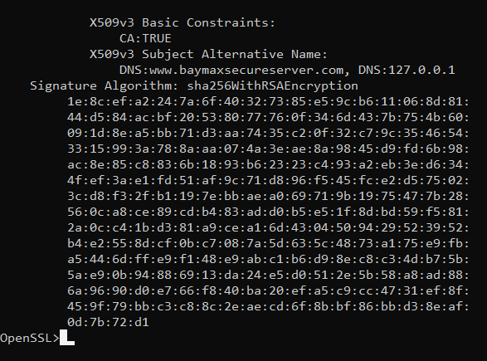

**Exporting the sub root CA key file in sub root CA pfx file:**

* x509 -in subrootCA.crt -outform der -out subrootCA.der
* pkcs12 -inkey subrootCA.key -in subrootCA.crt -export -out subrootCA.pfx

**Signing server certificate with sub root CA certificate:**

* x509 -req -CA subrootCA.crt -CAkey subrootCA.key -in server.csr -out server.crt -days 365 -CAcreateserial -extfile domain.ext
* x509 -in server.crt -outform der -out server.der

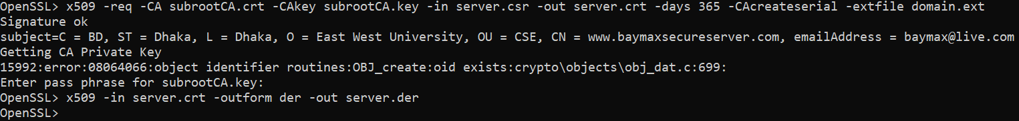

**Exporting the server key file in the server .pfx file:**

* pkcs12 -inkey server.key -in server.crt -export -out server.pfx

**Replacing the RSA encryption from the server and sub root CA key for setting the validity:**

* rsa -in server.key -out server.key
* rsa -in subrootCA.key -out subrootCA.key

Now we have to install those certificates. Go to ***‘C:\xampp\apache\bin’*** and install ***rootCA.crt*** and ***subrootCA.pfx***.

* Copy from that location ***‘server.crt’*** and replace with ***‘C:\xampp\apache\conf\ssl.crt\server.crt’***
* Copy from that location ***‘server.csr’*** and replace with ***‘C:\xampp\apache\conf\ssl.csr\server.csr’***
* Copy from that location ***‘server.key’*** and replace with ***‘C:\xampp\apache\conf\ssl.key\server.key’***

Lastly, go to ***‘C:\xampp\apache\conf\extra\httpd-vhosts.conf’*** and open in an editor and add these lines of code at the last for configuring ***httpd-vhosts***:

<VirtualHost *:443>

DocumentRoot "C:/baymaxSecureServer/"

ServerName baymaxsecureserver

ServerAlias www.baymaxsecureserver.com

SSLEngine on

SSLCertificateFile "conf/ssl.crt/server.crt"

SSLCertificateKeyFile "conf/ssl.key/server.key"

</VirtualHost>

**Revocation of certificate:**

* Go to ***‘C:\xampp\apache\bin’*** location and create file named ***‘subrootCA.conf’*** where this code will be written:

[ca]

default_ca = CA_default

[CA_default]

dir =C:/xampp/apache/bin

certs = $dir

crl_dir = $dir

new_certs_dir = $dir

database = $dir/index.txt

serial = $dir/serial.txt

RANDFILE = $dir/private/.rand

private_key = $dir/subrootCA.key

certificate = $dir/subrootCA.crt

crlnumber = $dir/crlnumber.txt

crl = $dir/crl/ca.crl

default_crl_days = 30

default_md = sha256

name_opt = ca_default

cert_opt = ca_default

default_days = 365

preserve = no

policy = policy_loose

[ policy_strict ]

countryName = supplied

stateOrProvinceName = supplied

organizationName = supplied

organizationalUnitName = optional

commonName = supplied

emailAddress = optional

[ policy_loose ]

countryName = optional

stateOrProvinceName = optional

localityName = optional

organizationName = optional

organizationalUnitName = optional

commonName = supplied

emailAddress = optional

[ req ]

# Options for the req tool, man req.

default_bits = 2048

distinguished_name = req_distinguished_name

string_mask = utf8only

default_md = sha256

# Extension to add when the -x509 option is used.

x509_extensions = v3_ca

[ req_distinguished_name ]

countryName = Country Name (2 letter code)

stateOrProvinceName = State or Province Name

localityName = Locality Name

0.organizationName = Organization Name

organizationalUnitName = Organizational Unit Name

commonName = Common Name

emailAddress = Email Address

countryName_default = BD

stateOrProvinceName_default = Dhaka

0.organizationName_default = EWU

[ v3_ca ]

# Extensions to apply when createing root ca

# Extensions for a typical CA, man x509v3_config

subjectKeyIdentifier = hash

authorityKeyIdentifier = keyid:always,issuer

basicConstraints = critical, CA:true

keyUsage = critical, digitalSignature, cRLSign, keyCertSign

[ v3_intermediate_ca ]

# Extensions to apply when creating intermediate or sub-ca

# Extensions for a typical intermediate CA, same man as above

subjectKeyIdentifier = hash

authorityKeyIdentifier = keyid:always,issuer

#pathlen:0 ensures no more sub-ca can be created below an intermediate

basicConstraints = critical, CA:true, pathlen:0

keyUsage = critical, digitalSignature, cRLSign, keyCertSign

crlDistributionPoints = @crl_dist_points

[ server_cert ]

# Extensions for server certificates

basicConstraints = CA:FALSE

nsComment = "OpenSSL Generated Server Certificate"

subjectKeyIdentifier = hash

authorityKeyIdentifier = keyid,issuer:always

keyUsage = nonRepudiation, digitalSignature, keyEncipherment

extendedKeyUsage = serverAuth

subjectAltName = @alt_names

[alt_names]

DNS.1 = www.baymxsecureserver.com

DNS.2 = 127.0.0.1

* Now we have to create some files in the same directory named ***index.txt***, ***serial.txt*** and ***crlnumber.txt***
* Open openssl.exe to revoke the certificate issued to verysecureserver.com from the Acme CA

ca -config subrootCA.conf -revoke server.crt

* To generate revocation crl file

ca -config subrootCA.conf -gencrl -out rev.crl

* To see the revocation file in the form of text

crl -in rev.crl -noout -text

**DNS Configuration Using Bind9:**

* **First we have to install bind9 from the below link and configure it like the 2 no video**
  + - * + <https://www.isc.org/bind/>
        + [https://www.youtube.com/watch?v=fsrny8RADZM](https://www.youtube.com/watch?v=fsrny8RADZM&fbclid=IwAR0_fvojMWU8l_guTFbUvXkc7JHye6L6THeIQqNDKtutMUHelnBWoEX4oJU)